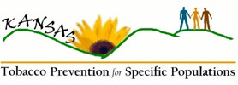

Kansas Tobacco Prevention Workgroup for Specific Populations
Chair/Co-chair Role & Responsibilities

Purpose of the Workgroup:
The purpose of the Kansas Tobacco Prevention Workgroup for Specific Populations is to work with the Kansas Department of Health and Environment (KDHE) to develop a strategic plan to address tobacco-related disparities in the State through a participatory process.

Role & Responsibilities of Workgroup Chair/Co-chair:
- To open meetings and welcome members.
- To serve in a leadership role on the Workgroup, e.g., following up with Workgroup members, etc.
- To participate in meetings and conference calls of the Disparities Planning Team.
- To moderate meetings, as needed.
- To monitor progress of tasks, keeping the group on schedule.
- To motivate and encourage regular attendance by members.
- To sign official communications, e.g., invitations to new members.

Signature:___________________________________

Printed Name: _______________________________

Date: _____________________



