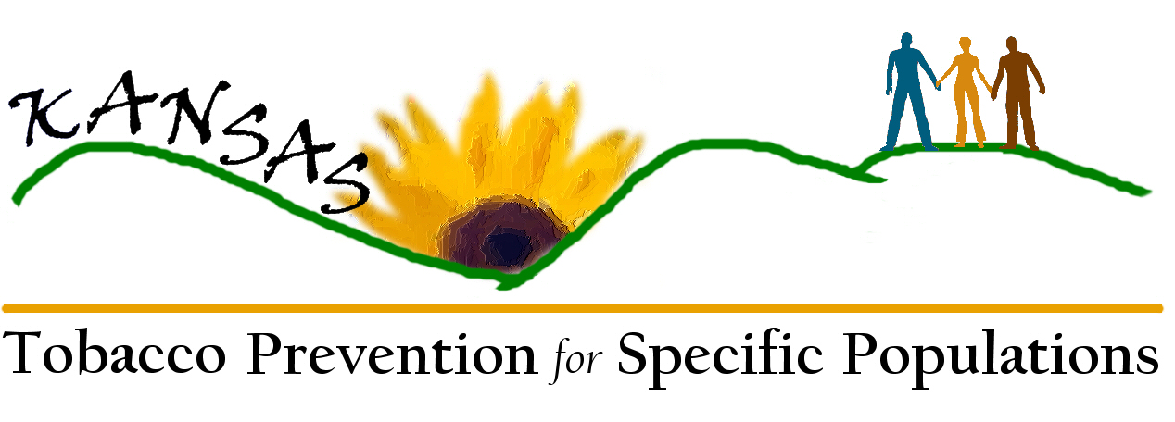
Specific Populations- Reportable Systems Changes (and incremental steps) as a direct result of the Disparities Funding Opportunity.

Kansas Tobacco Use Prevention Program, Kansas Department of Health and Environment Systems Changes to date:

- Offered technical assistance conference calls on cultural competency on Kansas Specific Populations. These technical assistance calls were open to Tobacco Use Prevention Program (TUPP) grantees, partners, Office of Local and Rural Health staff, Coordinated School Health grantees, TUPP staff and KDHE Office of Health Promotion staff. Technical assistance conference calls were taped and available by e-mail to those who were unable to participate at the scheduled time.
1. The first toll-free call held on April 3, 2007 was titled Engaging the Lesbian, Gay, Bisexual and Transgender Community in Tobacco Control Efforts. Scout, Ph.D. from the Fenway Institute, Boston, MA presented on the call. The first time TUPP utilized the KS TRAIN network to broadcast training opportunity throughout the state.
2. The second call titled Building Relations with the American Indian population and health care providers was held on June 3, 2007. Christine Makosky Daley, PhD, MA, SM, Research Assistant Professor, University of Kansas Medical Center, Department of Preventive Medicine and Public Health.

3. Three speakers from the Fenway Institute facilitated training in Topeka for TUPP grantees, TUPP staff, and other KDHE staff including the Wellness Representative, and the Office of Minority Health Director who attended in person or via ITV on April 27, 2007. A lobbyist from the Kansas Equality Coalition also presented during the training. A video of the day’s presentation was made and will be edited into a short training video.
- Collaborated directly with HK2010 and will continue to update participants on Priority Population efforts.
- Collaborating with the Kansas Mission of Mercy (KMOM) dental clinic that occurs annually in a selected region of the state. Attempts were made to be involved with the February 2 and 3, 2007 event but this was unsuccessful. Efforts are being made to be part of next year’s event. KMOM provides millions of dollars in free dental work during a two-day clinic offered annually to medically underserved and uninsured. Many other subpopulations of the Specific Populations initiative are patients at the clinic.
- The Office of Minority Health at the Kansas Department of Health and Environment has been renamed the “Center for Health Disparities.”
- Persons with limited mobility will now be self-reported on the Kansas Tobacco Quitline intake survey.
- LGBTIQQ populations are self-identified in both the Quitline calls during the intake part of the call, and in the Adult Tobacco Survey (ATS). The ATS is a random sample of Kansans over the age of 18. See specific verbiage below:
IMPORTANT TALKING POINTS:

The question should be asked in the same standard, nonchalant way all other questions are asked. No apologies, cautions, etc...
If the person answers TRANSGENDERED, choose "Other".
If the person does not understand the question or does not want to answer, use "Refused" and go on to the next question.
If the caller asks why we are asking:
1st RESPONSE - "We are gathering information to find out if services are reaching diverse populations and if they are effective.”
2ND RESPONSE - if the caller wants more information, you can elaborate with the following statement - "The information is kept completely confidential. No names or identifying information is given when the information is shared. If you have more questions, I can have someone contact you directly.”

90. Which of the following best describes how you think of yourself? (KS-sexpref)

READ:
1. Heterosexual or Straight
2. Gay
3. Lesbian
4. Bisexual
5. Other

DO NOT READ:
7. Don't know/Not sure
9. Refused of the call. Question is asked in this order: Heterosexual, Straight, Gay, Lesbian, Bisexual, Other: _________
- A Web site was established for workgroup participants, grantees, partners, HK2010 members, and other organizations working towards eliminating tobacco use disparities. http://www.healthykansans2010.org/tobacco/
- The Kansas Tobacco Prevention for Specific Populations Web site www.healthykansans2010.org/tobacco contains the project’s draft documents, Specific Populations links, American Legacy Foundation links, photos and all of the handouts and presentations from the process.
- The Web site was changed to be more accessible using Section 508 of the Rehabilitation Act as a standard. This amendment requires all government agency’s electronic and information technology to be accessible to people with disabilities. In this case, the definition of accessibility issues includes slower internet connections and lower resolution monitors. For more information about Section 508 go to http://www.section508.gov/index.cfm?FuseAction=Content&ID=12#Web
- Surveyed grantees and potential grantees at the Pre-bidder’s Conference in Salina on January 31, 2007. Grantees requested targeted resource materials. Brochures have been ordered and will be distributed via outreach coordinators and links are on the Web site.
- The Coalition of Hispanic Women Against Cancer received a grant and contacted the Quitline Manager to learn how to incorporate the Quitline into their action plan.
- Sac and Fox Casino is going smoke-free in the facility except the gaming floor. The casino held a wellness fair with tobacco cessation information and sent Quitline cards to employees as a payroll stuffer.
- Resources were circulated to the Specific Populations Workgroup, grantees and partners for targeted populations.
- Placed the Quitline number and logo on as many materials as appropriate for distribution at the Specific Populations meetings to create brand recognition.

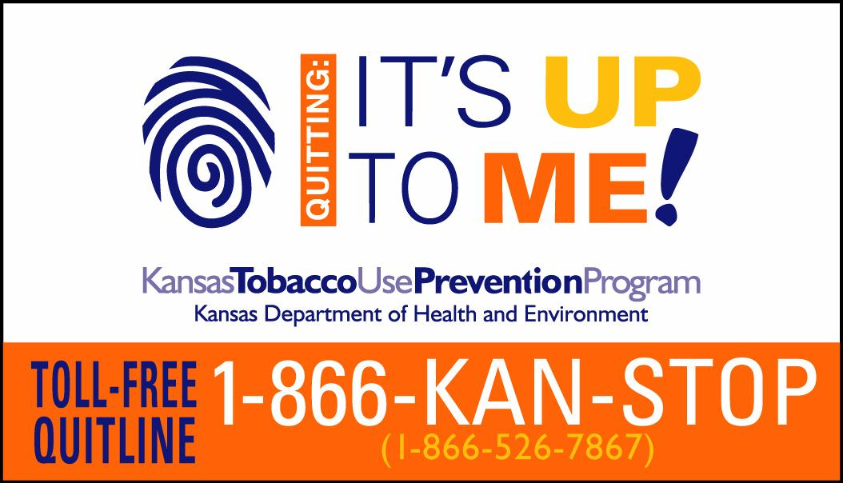
- Challenged workgroup members to make systems changes in their homes, communities and places of work to keep the momentum going and grow the number of systems changes exponentially. (A follow-up postcard with the “thank you” incentives with the Specific Populations logo and website, certificates and final documents will be mailed.)
- The tobacco and military workgroup has been revitalized by Quitline Manager, Becky Tuttle, with workgroup member Pete Weimers, Health Promotion Educator, Irwin Army Community Hospital. All three military sites in Kansas have contacted Becky and she has presented information on the Kansas Tobacco Quitline, the “5A’s of tobacco cessation in a clinical setting” and the fax referral form for military medical and oral health personnel.
- Three members of the Specific Population planning team participated in a military conference call with CDC in late 2007. One member, Jenna Hunter, will continue to serve on the military workgroup to represent the Specific Populations planning team.
- TASK, the state’s youth movement against tobacco, is conducting a Smokeless Does Not Mean Harmless Spit Tobacco Summit on August 29, 2007. Invitations have been sent statewide. Oral health professionals have been invited to a special breakout session offering 4.25 CEU’s (continuing education units) to educate them on how to recognize spit tobacco users and inform the professionals of ways to help spit tobacco users quit using the toll-free Kansas Tobacco Quitline.
- The Office of Local and Rural Health Promotora Program was contacted to verify if they are disseminating the toll-free Quitline number. The program was asked to specify incentives that TUPP can purchase specifically for the Low German Mennonite population. This program works with a migrant farm worker population, who speak Spanish and have very low literacy. The Quitline was not identified as being a practical message. This Palt Dietsch population is approximately 4,000 to 5,000 people mainly in Southwest Kansas. We continue to collaborate to see if we can reach this population in an effective way.
- Outreach Coordinators are disseminating Quitline cards in Spanish. The fax referral form has been available in Spanish for more than two years.
- Sedgwick County disseminated KS Quitline information at Pride Festival in Wichita targeting the LGBTIQQ population.
- Tobacco Free Kansas Coalition presented at one of the three Workgroup meetings and signed the Certificates of Participation to recognize the workgroup for their efforts and recruit statewide membership. The TFKC logo and web site was printed on the certificates for recruitment purposes and brand recognition.

- Consulted the national groups to design a reporting form to share with other bureau project coordinators, grantees, partners etc. Please refer to Handout 11 in notebooks.

- July 7, 2007 TUPP staff participated on a conference call with Betsy Mitchell at CDC who was surveying states to see what forms of technology they were using to disseminate information to their grantees and for counter-marketing purposes. Her research will give us some successful ideas to work with some of our specific populations such as youth. "Mitchell, Betsy (CDC/CCHP/NCCDPHP)" <bhm0@CDC.GOV>

Work in progress:
- It was recommended that TUPP staff and Specific Populations Workgroup team members sign up at the www.kNOwtobacco.net Web site set up by a contractor for CDC. This is a networking Web site that is closely monitored so resources should be valid and trustworthy.
- TUPP staff to join the American Legacy Web site on policy and distribute to partners, grantees, TFKC etc. www.tobaccopolicychange.org
- Karry is tracking the spreadsheet created by Workgroup participants who noted any efforts and changes in their workplace, offices, school, etc. since attending meetings such as posters displayed in all waiting rooms, distributing LGBT flyers etc. A reminder will be sent to the participants of their commitments and to ask for any additional progress updates.
- Kansas correctional facilities have gone tobacco-free and those who are incarcerated have to abstain from tobacco without assistance. We will check with American Cancer Society and appropriate personnel to see if we can approach correctional health care.
- Track any contacts and changes in materials and trainings targeting people who are incarcerated, homeless, institutionalized for mental health and addiction issues.
- Outreach Coordinators may be asked to attend priority population’s coalitions or meet with representatives across the state to build relationships and obtain comments or recruit participation in the next step of this initiative
- Currently Hunter Health is the only American Indian Clinic that we know of that is using the Quitline Fax referral form. Contact other clinics to offer Quitline resources and provider trainings addressing the 5A’s (Ask, Advise, Assess, Assist, Arrange).
- TUPP grant award process requires applicants to identify and work to eliminate disparities. Efforts will be made to continue to educate TUPP grantees on Best Practices and local successes.
- The Workgroup hopes to have the speaker who presented at CDC on behalf of the Legacy Foundation present at our next Pre-Bidder’s Workshop in January 2008. She specifically reviewed grantees who identified and targeted specific populations and what they had in common to gain success. [What does this sentence mean?]
- Magnets targeting the LGBT population are on order to give to TUPP grantees and partners who serve the LGBTIQQ population. They are customized with the Kansas Tobacco Quitline information.
- Place a Quitline advertisement in The Budget newspaper that serves the Sugarcreek area and the Amish/Mennonite communities throughout the Americas. TUPP has $500 to spend on these advertisements during the next year.
- Tracking our 6 month LGBTIQQ plan and reporting back to Fenway Institute.
- New Program Director Clarence Cryer is registered for the annual LGBTI anti-tobacco summit on October 23, 2007 in Minneapolis, MN.

Abstracts and Call for Presentations Submitted to:

Kansas Governor’s Health Conference, New Frontiers in Public Health, Hutchinson, KS April 30 - May 2, 2007. Presentation titled: Building a Diverse Workgroup to Successfully Tackle a Common Problem: Lessons Learned from the Tobacco Prevention Priority Population Project, was accepted and presented on April 4, 2007. Twenty participants attended the breakout session with10 interested in tobacco specifically and 10 interested in creating diverse workgroups.

2007 National Conference on Tobacco Or Health, October 24 - 26, 2007, Minneapolis, MN. The following abstracts were submitted March 5, 2007: 1. Implementing & Sustaining A Focus On Priority Populations Through Systems Change, 2. A Toolbox for Tobacco Prevention Strategic Planning Among Priority Populations. Both abstracts were accepted as posters.

Kansas Public Health Association call for presentations. Communicating our Message: Public Health, Politics and Policy 2007 Fall Public Health Conference, Wichita, KS, September 18 - 20, 2007. Application was submitted on April 30, 2007, but this abstract was not accepted for presentation.

2007 National LGBTI Anti-Tobacco Summit, Expanding Our Movement: Lessons from the Field, October 23, 2007, Minneapolis, MN. An abstract for a poster was submitted on August 14, 2007. Waiting to hear if the poster is accepted.

2008 AAHE (American Association for Health Education)/AAHPERD (American Alliance for Health, Physical Education, Recreation and Dance) Annual Conference, April 8-12 in Fort Worth, TX. Abstract submitted by contracted consultant, Janet M. Brandes, MPH, Educational Programs Coordinator, Health Services Management and Community Development Program, Department of Physician Assistant, Wichita State University. Waiting to hear if the abstract is accepted.

