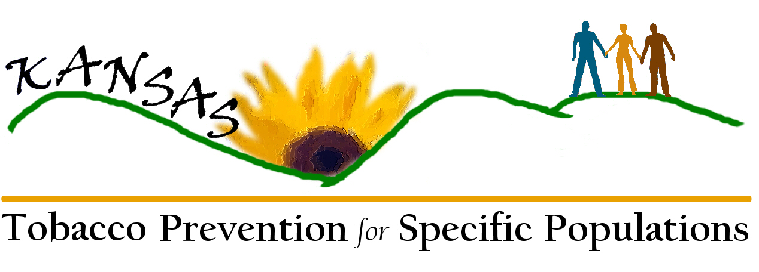
Tobacco Prevention for Specific Populations
Draft Critical Issues, Goals, and Strategies: Timeline

Goal: By June 30, 2010, all KS communities will have access to culturally and linguistically appropriate prevention and intervention resources for at least 4 specific populations. | June 07 | July-Sept 07 | Oct-Dec 07 | Jan-Mar 08 | Apr-June 08 | July-Sept 08 | Oct-Dec 08 | 2009 | 2010
1)Identify population: Identify 4 populations
1a)Evaluate & obtain data |  | X
1b)Create process to identify specific populations in greatest need. |  |  | X
2)Identify models: Identify potentially effective models and develop new models for existing gaps.
2a)Research existing models. |  |  | X
2b)Create directory of models. |  |  | X
2c)Identify gaps. |  |  |  |  | X
2d)Develop or modify models. |  |  |  |  | X
3)Disseminate: Develop a community network to eliminate barriers by providing access to effective population-specific models.
3a)Convene potential community partners. |  |  |  |  |  |  | X
3b)Identify access barriers. |  |  |  |  |  |  | X
3c)Develop web-based resource guide for population-specific prevention and intervention materials and techniques. |  |  |  |  |  |  |  | X
3d)Market website and provide training. |  |  |  |  |  |  |  | X
4)Evaluation: Evaluate dissemination process and network. |  |  |  |  |  |  |  |  | X

Goal: By June 30, 2009, there will be a functioning statewide strategy regarding collection, dissemination, integration and utilization of community-level quantitative and qualitative data to eliminate identified data gaps among specific populations. | June 07 | July-Sept 07 | Oct-Dec 07 | Jan-Mar 08 | Apr-June 08 | July-Sept 08 | Oct-Dec 08 | 2009 | 2010
1)Conduct comprehensive assessments of available data to examine the range of factors related to tobacco use among disparately-affected populations.
1a)Compile comprehensive sources of data in Kansas and nationally.
1b)Create directory of available resources.
1c)Complete report with relevant data to guide the strategic planning process and enrich disparities elimination efforts for tobacco control.
1d)Print report.
1e)Distribute report to key tobacco stakeholders and communities.
2)Improve existing surveillance systems and suggest modifications or additions.
2a)Catalog existing surveillance systems.
2b)Access existing surveillance systems and suggest modifications or additions.
2c)Identify specific minimum data set.
2d)Define requirements for improvement of surveys, including cost requirements.
2e)Identify funding sources.
2f)Secure funding.
2g)Finalize specifications.
2h)Disseminate recommendations.

Goal: By June 30, 2009, there will be a functioning statewide strategy regarding collection, dissemination, integration and utilization of community-level quantitative and qualitative data to eliminate identified data gaps among specific populations. (cont.) | June 07 | July-Sept 07 | Oct-Dec 07 | Jan-Mar 08 | Apr-June 08 | July-Sept 08 | Oct-Dec 08 | 2009 | 2010
3)Develop new data collection methods to access tobacco use where gaps in knowledge exist.
3a)Create a data task force.
3b)Review alternative sources of data, including qualitative data.
3c)Create and test innovative data collection methods.
3d)Implement, evaluate, share methods and new information.
3e)Explore the possibilities for data collection and industry targeting.
4)Disseminate available data to community key stakeholders.
4a)Create a county community resource guide.
4b)Use all available resources to disseminate information (print, electronic, media).
4c)Communicate resources nationally.
5)Link the data and data collection system with statewide and national tobacco prevention and cessation strategies.
5a)Evaluate use of data collection systems.
5b)Share information with national tobacco communities.
5c)Make recommendations for future research.
5d)Share data for utilization in health care curriculum.
5e)Use data as a method for additional funding.

Goal: By June 30, 2010, educate and motivate communities, funders, and policymakers to support the elimination of tobacco-related health disparities in Kansas. | June 07 | July-Sept 07 | Oct-Dec 07 | Jan-Mar 08 | Apr-June 08 | July-Sept 08 | Oct-Dec 08 | 2009 | 2010
1)By June 30, 2010, develop an integrated statewide advocacy plan to address tobacco-related health disparities. |  |  |  |  |  |  |  |  | X
1a)Convene the advocacy action planning team – regional representatives, state and private partners.
1b)Partner with local and state organizations to facilitate, train and provide data for advocacy action planning team.
1c)Research and convene Cabinet members and legislative leaders regarding the advocacy action plan.
2)By June 30, 2010, conduct a tobacco biannual training/meeting for communities, funders, and policymakers to support the elimination of tobacco disparities. |  |  |  |  |  |  |  |  | X
2a)Identify and convene communities, funders, policymakers, and stakeholders.
2b)Provide training for communities, funders, and policymakers regarding tobacco-related health disparities.
2c)Evaluate the training/meeting of the above groups.
3)By June 30, 2010, recruit and train a minimum of 5 sustainable community-based organizations per KDHE, TUPP (6) regions not previously involved in tobacco control work, in mobilization/implementation activities. |  |  |  |  |  |  |  |  | X
3a)Develop and deploy a recruiting campaign for new specific-population groups (not involved in tobacco control).
3b)Identify and recruit 5 community organizations for each region.
3c)Train each community organization in Tobacco 101 and Best Practices.
3d)Provide ongoing TA (online via website, evaluation).
3e)Select a project to complete in each region (e.g., clean indoor air).
3f)Evaluate the project (process, implementation) within each region.

