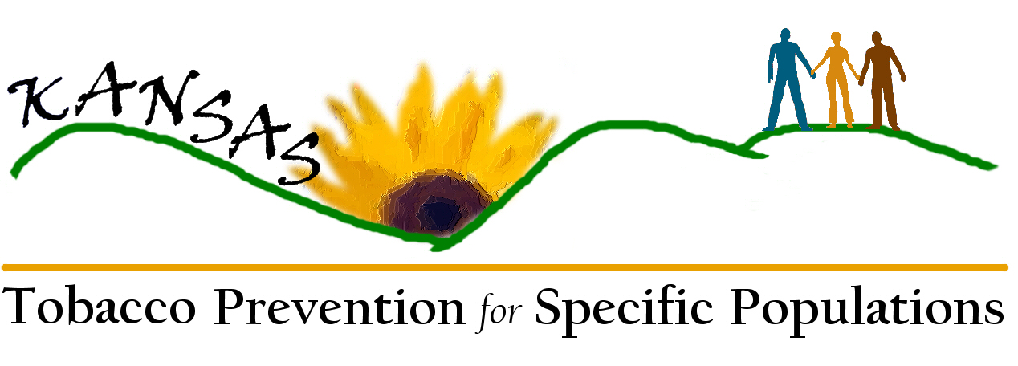

Specific Populations Other than Race/Ethnicity

Academics | Female lawyers | Non-English speaking
Advocacy | Fine art community | Non-profit
Alcoholics Anonymous | Fund raising | Nursing (male and female)
American Idol | Gambling | Parenting
Arts | Gangs | Party people
Auto Club | Gothic | Pets
Basketball,sports | Grandmother | Play cards
Beauty shop | Grassroots | Political
Bicycles | Health Administration | Pop culture
Biking | Health Care | Professional
Birdwatchers | Health Club | Public Health
Book Club | Hearing | Readers
Bunkos (dice game) | Heterosexual | Regional
Cancer | Immigrant | Research
Catholic | Intellectual | Rural
CBO | Interpreters | Schools
Choral Community | Job | Sewing
Church | Jocks | Shopping
Citizenship | Kansas | Sisters
Civic | Legal community | Social Service
Coalitions | Lesbian | Sorority/Fraternity
Computer Technician | LGBT | Sports
Construction | Love bird | State
County | Low SES | Student
Couples | Medical | Suburb
Daughters | Medically indigent | Theatre
Disability Community | Mennonite | Tobacco Prevention
Early Childhood | Mental Health | Translators
Economics | Middle to upper socioeconomic | Travel
Educators | Migrant | University
Engineers | Military | Urban
English speaking | Mobility issues | Veterans
Extended family | Mothers | Vision issues
Faith/Church | Motorcycles | Volunteer Service
Family | Music - Rap, Country, R&B, Pop, Rock, Christian, Jazz | Women
Farmers | Neighborhood | Work
Federal | Nerds | Youth

