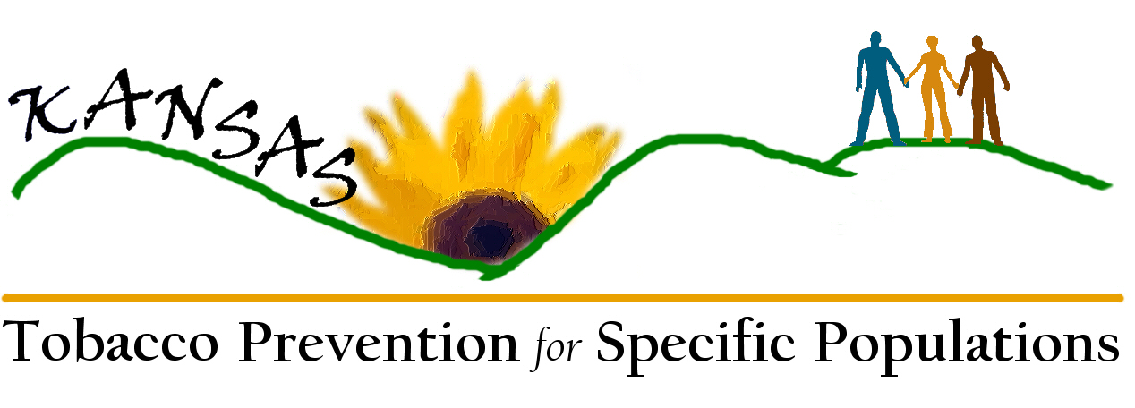
Tobacco Prevention for Specific Populations
Draft Critical Issues, Goals, and Strategies

Specific Population Interventions

Critical Issue: Increase population-specific interventions that can be integrated in to community programs.

Goal: By June 30, 2010, all KS communities will have access to culturally and linguistically appropriate prevention and intervention resources for at least 4 specific populations.

Strategies:

- Identify population: Identify 4 populations based on current and evolving data.

  - Evaluate and obtain data.
- Who: KDHE
- When: September 2007
- Resources: People, time, data, data resources (BRFSS, Census data)

  - Create a process to identify specific populations in greatest need.
- Who: TUPP
- When: December 2007 (6 months)
- Resources: People

- Identify models: Identify potentially effective models and develop new models for existing gaps.

  - Research existing models.
- Who: KDHE/TUPP
- When: December 2007 (6 months)
- Resources: CDC, web sites, Best Practices book, Cancer Control, Lung Association

  - Create directory of models.
- Who: KDHE
- When: December 2007 (6 months) (completed simultaneously with research step)
- Resources: CDC, web sites, Best Practices book, Cancer Control, Lung Association

  - Identify gaps.
- Who: Create Assessment Team.
- When: June 2008 (1 year)
- Resources: Need data. Other resources same as above (CDC, web sites, Best Practices book, Cancer Control, Lung Association)

  - Develop or modify models.
- Who: Assessment team and TUPP
- When: June 2008 (1 year)
- Resources: Need data. Other resources same as above (CDC, web sites, Best Practices book, Cancer Control, Lung Association)

- Disseminate: Develop a community network to eliminate barriers by providing access to effective population-specific models.

  - Convene potential community partners.
- Who: KDHE/TUPP
- When: December 2008
- Resources: Meeting location, facilitator, incentives, funding

    - Identify access barriers.
- Who: Assessment Team and Community Partners
- When: December 2008
- Resources: Meeting location, facilitator, incentives, funding, CDC, internet, best practices, people

- Develop web-based resource guide for population-specific prevention and intervention materials and techniques.
- Who: KDHE/TUPP
- When: June 2009
- Resources: I.T., funding, website, people

- Market website and provide training.
- Who: KDHE/TUPP
- When: December 2009
- Resources: I.T., funding, website, people

- Evaluation: Evaluate dissemination process and network.
- Who: KDHE, TUPP, Assessment Team
- When: June 2010 (3 years)
- Resources: Staff, data analysis, access to report from agencies

Data

Critical Issue: Increase community-level quantitative and qualitative data to eliminate identified data gaps among selected populations.

Goal: By June 30 2009, there will be a functioning statewide strategy regarding collection, dissemination, integration, and utilization of community-level quantitative and qualitative data to eliminate identified data gaps among specific populations.

Strategies:

- Conduct comprehensive assessments of available data to examine the range of factors related to tobacco use among disparately-affected populations.

  - Compile comprehensive sources of data in Kansas and nationally.
- Who: KDHE
- When: Immediately. By January 2008
- Resources: Data access, human resources

  - Create directory of available resources.

  - Complete report with relevant data to guide the strategic planning process and enrich disparities elimination efforts for tobacco control.

  - Print report.
- Who: KDHE

  - Distribute report to key tobacco stakeholders and communities.

- Improve existing surveillance systems for data collection.

  - Catalog existing surveillance systems.
- Who: Data Task Force

  - Access existing surveillance systems and suggest modifications or additions.
- Who: Data Task Force

  - Identify specific minimum data set.
- Who: Data Task Force

  - Define requirements for improvement of surveys, including cost requirements.
- Who: Data Task Force

  - Identify funding sources.
- Who: Data Task Force

  - Secure funding.
- Who: Data Task Force

  - Finalize specifications.
- Who: Data Task Force

  - Disseminate recommendations.
- Who: Data Task Force

- Develop new data collection methods to access tobacco use where gaps in knowledge exist.

  - Create a Data Task Force.

  - Review alternative sources of data, including qualitative data.

  - Create and test innovative data collection methods

  - Implement, evaluate, share methods and new information.

  - Explore the possibilities for data collection around industry targeting.

- Disseminate available data to community key stakeholders.

  - Create a county community resource guide.

  - Use all available resources to disseminate information (print, electronic, media).

  - Communicate resources nationally.

- Link the data and data collection system with statewide and national tobacco prevention and cessation strategies.

  - Evaluate use of data collection systems.

  - Share information with national tobacco communities.

  - Make recommendations for future research.

  - Share data for utilization in health care curriculum.

  - Use data as method for additional funding.

Advocacy and Policy

Critical Issue: Educate and motivate communities, funders, and policymakers to support the elimination of tobacco disparities.

Goal: By June 30, 2010, educate and motivate communities, funders, and policymakers to support the elimination of tobacco-related health disparities in Kansas.

Strategies:

- By June 30, 2010, develop an integrated statewide advocacy plan to address tobacco-related health disparities.
  - Convene the advocacy action planning team – regional representatives, state and private partners.
- Who: TUPP staff
- When: Yearly
- Resources: Trainers, locations, materials, collaborate with partners (heart, lung, cancer; state and private)

  - Partner with local and state organizations to facilitate, train, and provide data for advocacy action planning team.
- Who: TUPP, TFKC
- When: Yearly
- Resources: Trainers, locations, materials, partners

  - Reach and convene the Cabinet members and legislative leaders regarding the advocacy action plan.
- Who: TFKC and other partners
- When: Biannual
- Resources: Coalitions, TUPP, TFKC

- By June 30, 2010, conduct a tobacco biannual training/meeting for communities, funders, and policymakers to support the elimination of tobacco disparities.

  - Identify and convene communities, funders, policy maker(s), and stakeholders.
- Who: Local Coalition (6 TUPP Regions)
- When: Yearly
- Resources: Trainers, location, materials, collaborate with existing partners (state and private)

  - Provide training for communities, funders, and policymakers regarding tobacco-related health disparities.

  - Evaluate the training/meeting of the above groups.

- By June 30, 2010, recruit and train a minimum of 5 sustainable community-based organizations per KDHE, TUPP (6) regions not previously involved in tobacco control work, in mobilization/implementation activities.

  - Develop and deploy a recruiting campaign for new specific-population groups (not involved in tobacco).
- Who: TUPP
- When: ongoing
- Resources: “mtk” [marketing?], materials, “HD” [health department?]

  - Identify and recruit 5 community organizations for each region.

  - Train each community organization in Tobacco 101 and Best Practices.

  - Provide ongoing TA (online via website-site, evaluation).

  - Select a project to complete in each region (e.g., clean indoor air).

  - Evaluate the project (process, implementation) within each region.
- Who: TUPP
- When: Ongoing
- Resources: Workgroup for Specific Populations, TUPP, “HD” [health department?], coalitions

