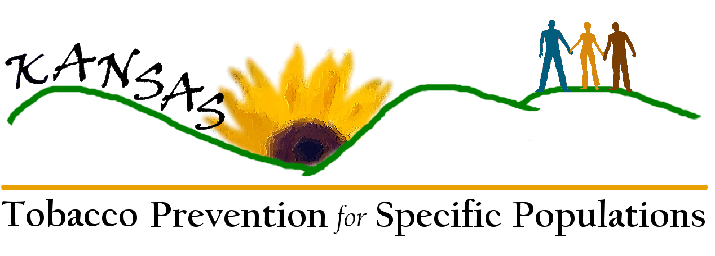
Meeting 3 (May 24th) Flip Chart Notes

Critical Issues, Goals, and Strategies

Specific Population Interventions Comments
- Data they will consider
  - Demographic
  - Prevalence
  - Impact Data
- Directory of Models:
  - Identify what makes it work
  - Communities of Excellence
- Comments on the Specific Populations Plan
  - A lot hinges on data: goal/strategies need to come first
  - Looking at data – what we have – analysis & interpretation
- Weighted to TUPP – use other partners more effectively (e.g., Center for Health Disparities)

Data Comments
- Q: Addressing line of authority – data collection – epidemiologist/task force
- Finding out what data the community needs and making it usable
- KS Substance Abuse Profile Group – meet on a quarterly basis
- Could we get a university student project to help with data process
- Identify data tools
- HK2010 data workgroup
- Data task force – helps in identifying data needs

Advocacy & Policy Comments
- Advocacy Action Team (needs to be recognized)
- Will utilize data/info/models from other action teams

Recommendations for Moving Forward
- Identify lead person to oversee plan implementation
- Have a chair person for each group (data action team, assessment action team)
- System/Mechanism for integration between action teams
- Plan format
  - Data
  - Interventions
  - Policy/Advocacy

Future Role of Workgroup
- Reconvene workgroup two times/year (in person, preferably) (Spring 08, October Tobacco Summit)
- Receive KDHE communications (TA, announcements of training, RFPs); note communications “Re: Specific Populations Opportunity)
- Create action teams, Visual timeline, Workgroup members volunteer to serve on action teams

Marketing Plan

Marketing
- Who does the plan need to get to?
- How best to reach tem?
- How will the materials be distributed?

Key Audiences
- Health care educators
- GLBT/Medical Association
- KSNA
- Legislators/Funders/Policy-makers
- Universities
- Safety-net clinics
- County, state, and national organizations
- KPHA
- KALHD
- Accrediting bodies
- Foundations
- KAMU
- Faith communities
- Own organizations
- Chambers of commerce (Hispanic, etc.)
- League of Municipalities
- KS Association of Counties
- Disability Coalitions
- VA/DAV
- HUD

Methods/Strategies
- Canned PowerPoint
- Personal relationships
- Presentations
- Core message tailored to audience
- Use their vehicle (website, annual meeting, newsletter)
- One page talking points
- Pictures with meaning
- Visuals/color graphics
- Fact sheets – specific to populations
- Website links
- Directory of resources (data, models)
- Involve specific population in materials developed (pre-testing of messages and design)
- Consider the “when”; when messages are being delivered

Political/Media Considerations
- Timing
- Approach & delivery
- Consider “power equity” – someone from similar level delivery the message
- Politicians – deliver from multiple constituencies simultaneously
Political/Media Considerations, continued
- Identify/being aware of political “loyalties”
- Capitalizing on “teachable moments”
- Is a process – working with politicians, etc.

Messages
- Outcomes
- Cost-benefit
- Impact
- Empowering local communities vs dictating
- Give example of where it’s working and they can relate to
- Integration (common issue, common problem)
- Enhancing current mission
- Family-oriented message
- Cost to community
- Implementation – will get data and resources for your work/community at no additional cost
- Enhances what you’re doing
- “Everyone deserves clean air”
- “Clean air – good for business, good for people”
- Health disparities exist. Give specific example.
- “K.A.N.S.A.S.: Klean Air No Smoking and Spitting”
- Give a specific call to action for each group
  - Cultural groups - NAACP
  - Union/labor groups – AAUP (American Academy of University Professors)

Distribution Channels
- Youth – MySpace
- Events: Concerts, ballgames
- T-shirts: Branding, messaging, school colors/logo
- Alternative newspapers
- Rec centers
- YMCA
- 4-H
- Web-based college assignments
- Connection to Blackboard
- Movie slides
- Posters, flyer contests – elementary/middle schools; award, casting calls
- Billboard (check on empty space – donations)
- Branding in movie theaters
- Screensavers
- Face-to-face/one-on-one for some populations; approach by trusted community/association leaders
- Culture sensitivity training (TA/marketing/media) for anyone involved in this work
- Tools for delivery the message/materials added to website

