Systems Changes

- Consult the national groups.
- Offer technical assistance calls on cultural competency on any of the KS Specific Populations.
- Collaborate directly with HK2010 and continue to update participants on Priority Population efforts.
- Office of Minority Health has been renamed “Center for Health Disparities” at Kansas Department of Health and Environment.
- Persons with a disability will now be self reported on the Kansas Quitline intake survey.
- LGBT populations are self identified in the Quitline intake portion of the call.
- The website was changed to be more accessible using Section 508 of the Rehabilitation Act as a standard.
- Surveyed grantees and potential grantees at the Pre-bidder’s Conference in Salina on January 31, 2007.
- The Coalition for Hispanic Women received a grant and contacted the Quitline manager to see how they can incorporate the Quitline into their action plan.
- Sent Quitline cards to Sac and Fox casino employees as a payroll stuffer.
- Established a website for workgroup participants, grantees, partners, HK2010 members, other organizations working towards eliminating tobacco use disparities. http://www.healthykansans2010.org/tobacco/
- Circulated targeted resources to the Specific Populations Workgroup.
- Create a master book of targeted materials to be kept by the Media and Policy coordinator in Topeka.
- Place the Quitline and logo on as many materials as appropriate for distribution at the Specific Populations meetings. To create “brand recognition” of the logo and recognition of the Quitline Number.

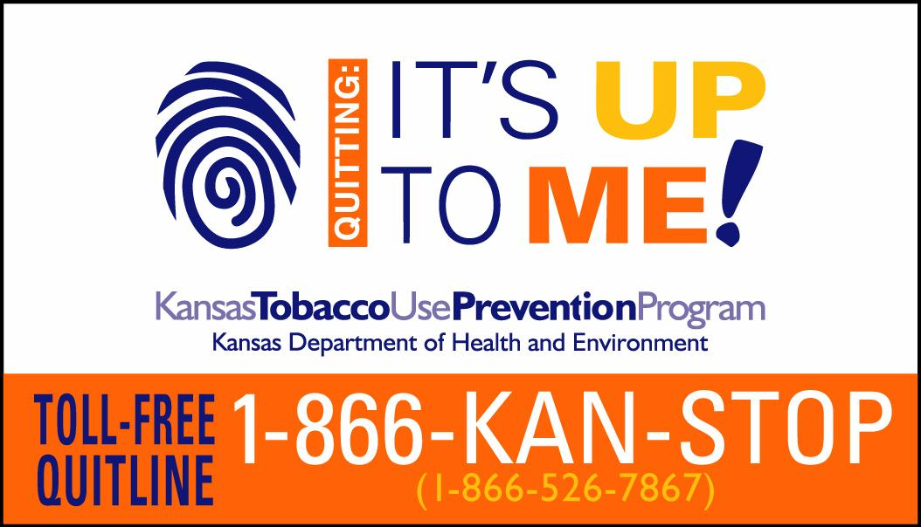
- Challenge workgroup members to make systems changes in their homes, communities and places of work to keep the momentum going and grow the number of systems changes exponentially!!!
- KDHE staff to join the American Legacy website on policy and distribute to partners, grantees, TFKC etc.
- Create some type of spreadsheet for workgroup participants to add any efforts and changes in their workplace, offices, school etc since attending meetings such as posters displayed in all waiting rooms, distributing LGBT flyers etc.

