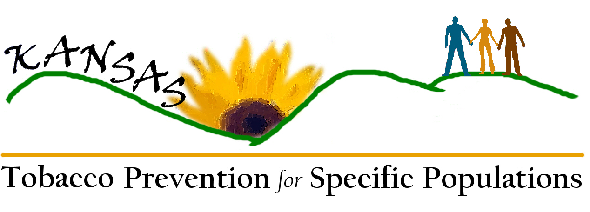
Specific Populations Represented by and/or
Served by Workgroup Members

1. People with low socio-economic status (SES) 
2. Black/African Americans
3. Asian Americans & Pacific Islanders
4. American Indians/Alaskan Natives
5. Hispanic/Latino
6. Gay/lesbian/bisexual/transgender
7. Medically underserved/uninsured
8. Young people (middle school/high school age youth)
9. Pregnant women
10. People facing mental or emotional challenges
11. People living with disabilities
12. Groups and affiliations for which tobacco-related disparities may be unidentified, including:
Migrant
German Mennonites
Faith Communities
Vietnamese
Refugees
Middle Eastern/Arab
Homeless
Documented and Undocumented Immigrants
Rural/Frontier
Military
Other

