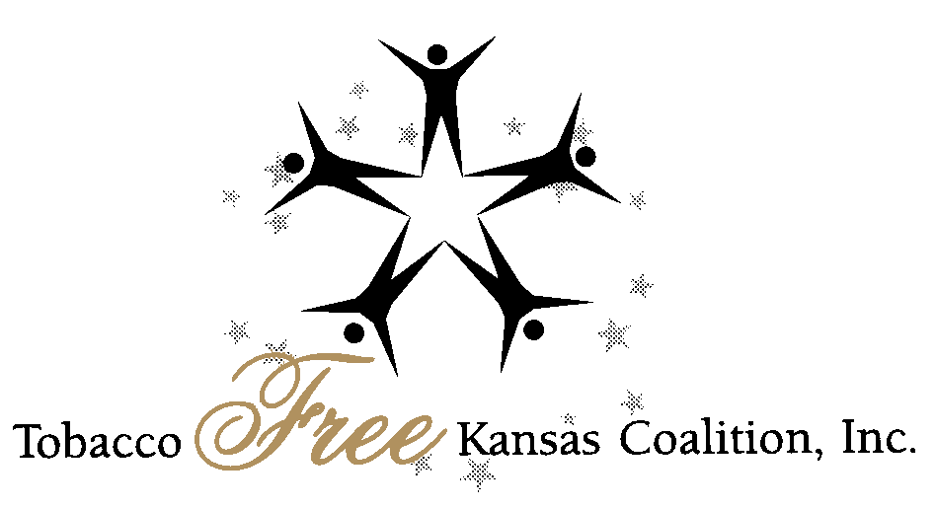
KANSAS LEGISLATIVE WRAP UP FOR
TOBACCO CONTROL ADVOCATES
May 2, 2007

The legislature has finished its work this year, with budget bills that relate to tobacco control issues.

- SB 2368: Retention of $1 million in tobacco prevention funding for KDHE from Children’s Initiative Funding.
- SB 357: Allocation of an additional $400,000 in funding for SRS to continue its programming to reduce illegal tobacco sales to youth.
- SB 318: Allocation of all “bonus” payment increases from the strategic contributions fund of the Master Settlement Agreement to KPERS for a special account within the Kansas Endowment for Youth Fund, with stipulations that no expenditures may be made without prior legislative approval.

Note: Tobacco control advocates have been promoting SB 318, which would have allocated the entire bonus payment to tobacco prevention and cessation programs. With SB 357, this potential funding of $16.8 million in FY 08 went into a holding pattern without specific allocation to other programs, after the conference committee agreed to remove the House’s recommendation that the increase be set aside in a health care reserve fund.

There is still much work for the next legislative session in securing more funding for tobacco prevention and cessation. However, this legislative session did provide an increase of $400,000 for tobacco control efforts. Also, the governor is speaking of the possibility of a tax increase on cigarettes as a way to reduce smoking prevalence while funding health initiatives. It will be up to the people of Kansas to demonstrate that funding tobacco prevention and cessation programs from MSA and cigarette taxes is a logical and effective way to improve the health of all Kansans. SB 37 was a significant smokefree bill, introduced by Senator David Wysong, with the original intention of making most public places smokefree. Hopefully, a legislative interim committee will also study the best ways to reduce exposure to second hand smoke in Kansas communities as a follow up of SB 37.

Other tobacco related bills were introduced but none was able to claim a hearing this year. However, this year TFKC advocates were invited to testify on SB 318 and SB 37, and worked with legislative partners on bill drafting.

