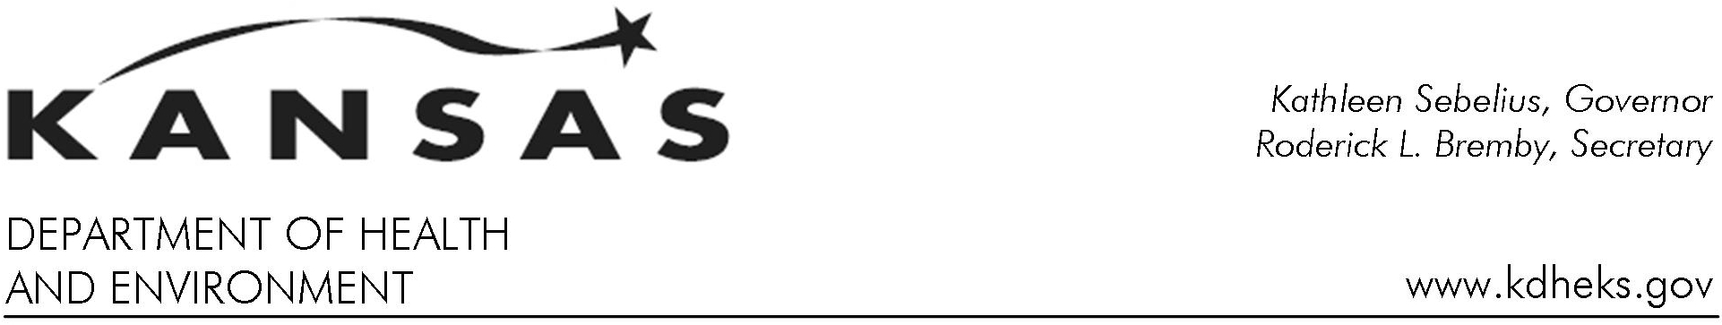

Publicity Consent and Release Agreement

Individuals/students/minors are occasionally asked to be a part of the Kansas Department of Health and Environment (KDHE) publicity, publications and/or public relations activities. In order to guarantee their privacy and ensure their agreement for participation, KDHE asks that this form be signed.

The form referenced below indicates approval for their names, portraits (video or still) and words, to appear in KDHE publications, videos or on KDHE Web sites. These pictures and articles may or may not personally identify the individuals/students/minors. The pictures, videos and/or words may be used by KDHE in subsequent years.

Agreement

I release to KDHE my, or the minor’s child name, portraits (video or still) and/or words and consent to their use by KDHE.

KDHE agrees that the name, portraits (video or still) and/or words shall only be used for any public relations, public information, publicity, Web sites and instruction.

I understand and agree that:
- No monetary consideration shall be paid;
- Consent and release have been given without coercion or duress;
- This agreement is binding upon heirs and/or future legal representatives;
- The name and portraits (video or still) may be used in subsequent years.

Effective Date of Agreement : __ __ /__ __ / __ __ __ __
If you wish to rescind this agreement you may do so at any time with written notice.

Name: ____________________________________________________________
(Print Name as you wish it used)

Written Signature: _______________________________________________ Status: ______________________
(Parent or legal guardian sign for minor) (Father, Mother, Guardian, etc.)

Witness: __________________________________ Written Signature: ___________________________________
(KDHE employee)( Print Name)

Bureau:________________________ Telephone Number : Area Code (____) ____ -_____ Extension (____)

