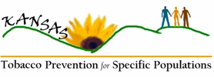

Workgroup Participant Biography:

Please share information about yourself with the workgroup. The following questions are meant as a prompt and you can answer as many or few as you feel comfortable.

- Any biographical information that you would like to share-education, vocation, areas you have lived?
- Hobbies, special interests or passions?
- What do you think is the number one public health issue in Kansas?
- What is the #1 public health issue that affects the people you serve/in your community?
- Have you, or someone close to you, been affected by tobacco?
- What makes your specific population/organization unique or distinctive where tobacco use is concerned?

Please return to: AHEC, PO Box 296, Pittsburg KS 66762 or fax 620-235-4871

