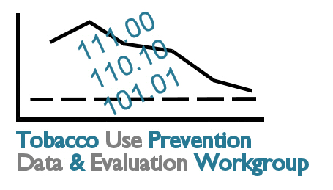
Meeting 4 Flip Chart Notes

Disparities Prioritization

- (7 votes) Develop better reporting by: Age, Gender, Race/Ethnicity, Pregnant Females

- (5 votes) Define broad-based minimum data set for tobacco prevention
  - Includes data standards and definitions
  - Includes determining best way to track progress for disparities (ratio, percent improvement, difference)

- (3 votes) Geographic-specific (zip, county)

- (3 votes) Research best ways to aggregate and stratify tobacco-related data, including addressing small number considerations

- (1 vote) Develop better reporting of low socioeconomic (SES) indicators, including income, education, employment, and occupation indicators

- (0 votes) Cultural competency and health literacy

Additional Comments Related to Review of Disparities Plans from Other Initiatives

- Data for same groups targeted by tobacco companies; look at how tobacco companies are targeting populations; analyze review data in the same way

- Several organizations do not have collaborative strategic plans:
  - Coordinating planning efforts at local level
  - Importance of sharing plans/ collaborating/coordinating between state-level organizations, state and local organizations

- Importance of looking at disparities in a positive way: if a particular population is doing well, why and is there anything that can be learned/applied to other populations?

- Cost/benefit; potential of applying more sources to certain specific population efforts to get greater benefit.

- Need vs. prevalence or number affected (i.e., some populations may have a high “need” or prevalence but low numbers vs. other populations with low prevalence but high numbers, especially related to geographic disparities)

Other Planning Efforts that Should Be Consulted for Improved Coordination among Partners

In addition to those plans reviewed in the documentation provided at the meeting, it is recommended that information from these organizations or plans also be consulted:

- State Cardiovascular Health Plan
- Diabetes Plan
- Healthy Kansans 2010
- American Cancer Society of Northeast Kansas
- KDHE Tobacco Use Prevention Program (TUPP) Strategic Plan
- Center for Health Disparities Strategic Plan
- Department of Revenue Plan – Synar
- State Injury Plan
- Maternal Child Health Needs Assessment
- Child Death Review Board
- State Oral Health Plan
- Coordinated School Health
- Healthy Start
- WIC
- SRS/Regional Prevention Centers (RPCs)/ Alcohol Beverage Control (ABC) – Retailer Education Plan
- Regional Prevention Centers
- Kansas Chamber of Commerce
- Kansas Parks and Recreation

Prioritization of Cross-Cutting Themes/
Collaboration Opportunities

- (8 votes) Registry/Information Hub
- (2 votes) Lack of resources/leverage resources
- (2 votes) Highlight economic burden/economic statistics
- (1 vote) Coordinate with other plans/initiatives
- Social marketing
- Health Insurance Data
- Further develop mortality/morbidity
- Stratify data by: smokers, secondhand smoke, spit tobacco, nonsmokers
- Advocacy

Additional Comment Related to Other Information that came from Cross-Cutting Themes Discussion

- Have listing of Master Settlement Fund available

Comments Related to Registry/Information Hub

- Clearinghouse – having information in one place
- Would like to have trends; multi-year data
- All parts mentioned are important to the registry/information hub
- Thinking data first, then policy
- Thinking policies are part of data
- Step 1: Compiling what is already available
- Step 2: Develop/compile new data
- Would like to know what policies are there and quality of the policies

Comments on How to Use the Evaluation Plan and Resulting Evaluation Report

- KDHE TUPP – state program will use
- Local communities
- Planning, monitoring progress, and successes (will also be used to help define success)
- Marketing
- Advocate for changes in local communities
- Cost/benefit
- Identifying what further needs to be done
- Provides coordination opportunities for other health areas
- Helps answer detailed questions from policy makers

