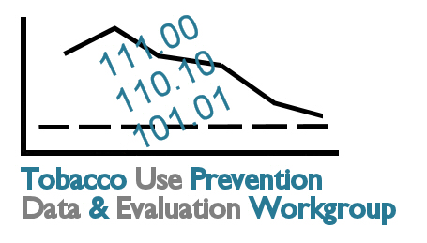
Cross-Cutting Themes

- Up-to-date Registry or Information Hub for…
  - Cessation Resources
  - Workplace policies
  - School policies
  - Local ordinances
  - Programs
  - Must be maintained regularly; potential data source for more detail
  - KNOwtobacco.net is a possible location for the information hub.

- How will this be coordinated with other evaluation plans? Provide information on other plans and/or a cross walk between plans at the next meeting.

- Lack of resources across the board. Need to leverage resources as best as possible by…
  - Encouraging collaboration
  - Building capacity at local level

- Increased social marketing
  - Need personal connection, stories (with other data)

- Highlight economic burden/economic statistics
  - Burden on nonsmokers
  - Burden related to health insurance

- Mortality/morbidity
  - Full potential of data from new death certificate has yet to be realized, completely analyzed.
  - Need more research on multiple cause codes versus underlying cause – with Kansas data.

- Whenever possible, stratify data by…
  - Smokers
  - Nonsmokers
  - Exposed to secondhand smoke
  - Spit tobacco users

Disparities

- Need more specific geographic information
  - Zip code, whenever available
  - County

- Low SES
  - Youth – proxy is highest level of educational attainment of parent
  - Pregnant women – mom’s education; also looking at father’s education
  - Household income
  - Occupational information (especially related to policy)
    - Data currently underutilized

- Data for the following three variables in uni- and multivariate format (e.g., tobacco use by age and tobacco use by age by race for pregnant females)
  - Pregnant females
  - Age
  - Race

- Small numbers continue to be an issue for Kansas. Report stratifications “whenever possible”

- Research: when faced with small number problems, what are the best ways to aggregate data (including which variables) for this issue?

- Create minimum data set for tobacco prevention
  - Include OMB 15 race/ethnicity categories
  - Achieve buy-in from all partners

- Provide group with a crosswalk of this and other plans related to disparities (HK2010, Specific Populations)

- How should disparities be measured? (difference, ratio, % improvement)

