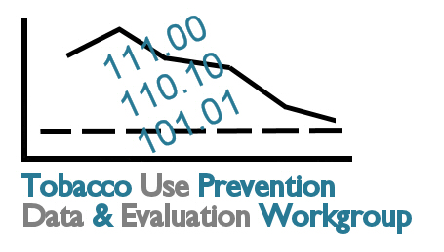
Tobacco Data and Evaluation
Planning Process: Meeting 2
September 5, 2007
Topeka Public Library
Marvin Auditorium 101C
10:00 a.m. – 3:00 p.m.

10:00 Introductions

10:10 Review of Meeting 1 Progress Harlen Hays
Overview of Meeting 2 Objectives
- Assumptions:
  - Kansas tobacco prevention will address all outcomes in each goal area.
  - The goal of the Kansas evaluation plan is to measure progress at the state level.
- Select indicators for each goal area to be included in the Kansas Tobacco Prevention Evaluation Plan.

10:20 State Comprehensive Tobacco Program Evaluation Plans: A Multi-State Scan Kim Kimminau

10:50 A Data and Evaluation Case Study: The Kansas Tobacco Quitline Becky Tuttle

11:05 Form Small Groups by Goal Area Connie Satzler
Review Small Group Tasks
Note: Goal Area 4, Disparities, will be addressed in all three small groups.
Goal Area 1. Youth
Goal Area 2. Secondhand Smoke
Goal Area 3. Cessation

11:20 Long-Term Outcomes Small Group Discussion
Review Long-Term Outcomes and Indicators
Recommend up to 2 indicators per outcome for the Kansas Tobacco Prevention Evaluation Plan

Note: Your small group should schedule a 45-minute lunch break during this time. The three small groups may wish to stagger lunch breaks to minimize waits in line at the café.

1:00 Report Recommended Long-Term Indicators to Large Group: 5 minutes per Small Group
Discussion/Consensus

1:15 Intermediate Outcomes Small Group Discussion
Review Intermediate Outcomes and Indicators
Recommend up to 3 indicators per outcome for the Kansas Tobacco Prevention Evaluation Plan

1:50 Report Recommended Intermediate Indicators to Large Group: 5 minutes per Small Group
Discussion/Consensus

2:05 Short-Term Outcomes Small Group Discussion
Review Short-Term Outcomes and Indicators
Recommend up to 4 indicators per outcome for the Kansas Tobacco Prevention Evaluation Plan

2:40 Report Recommended Short-Term Indicators to Large Group: 5 minutes per Small Group
Discussion/Consensus

2:55 Review Progress Connie Satzler
Next Steps: Meeting 3 Objectives

3:00 Adjourn

Next Meeting: 10 a.m. – 3 p.m., Friday, September 14th, SRS Learning Center

Questions before the next meeting? Contact Connie Satzler, (785) 587-0151 or csatzler@kansas.net or check the
workgroup website: www.healthykansans2010.org/TUPP

