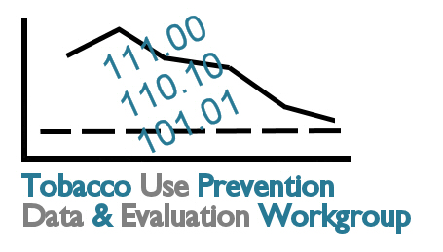
Kansas Tobacco Data and Evaluation
Planning Process
Invited Organizations
.

Addiction and Prevention Services, SRS
American Cancer Society
American Heart Association
American Lung Association of the Central States
Attorney General’s Office
Blue Cross Blue Shield of Kansas
KDHE Bureau of Family Health
Butler County School Resource Officer
Department of Revenue
EnVisage Consulting, Inc.
Governor's Office
Greenbush
Johnson County Health Department
Juvenile Justice Authority
Kansas Association for the Medically Underserved
Kansas Association of Local Health Departments
Kansas Cancer Registry
Kansas Center for Health Disparities
Kansas Dental Association
Kansas Department of Education
Kansas Department of Revenue
Kansas Family Partnership
Kansas Foundation for Medical Care
Kansas Health Institute
Kansas Health Policy Authority
Kansas Hospital Association
Kansas Parks and Recreation
KC-MPH Program University of KS Medical Center
KDHE Office of Health Promotion
KDHE Office of Oral Health
KDHE TUPP
KDHE Bureau of Family Health
KDHE Office of Health Assessment
KDHE Office of Health Promotion
KDHE Office of Oral Health
March of Dimes
Salina/Saline County Health Department
Shawnee Regional Prevention and Recovery Services
SRS
Sunflower Foundation
Tobacco Free Kansas Coalition
Tobacco Use Prevention Program
University of Kansas Medical Center Department of Family Medicine
University of Kansas Medical Center Department of Preventive Medicine
University of Kansas Department of Preventive Medicine and Public Health
University of Kansas School of Medicine

If you notice an organization not listed here that should be invited to review and comment on the draft evaluation plan, please
- Send name and contact information to Connie at csatzler@kansas.net.
- Let us know if we can share your name when inviting the recommended individual to review the plan.

