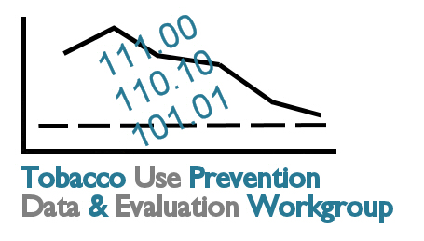

Tobacco Data and Evaluation Planning Process: Meeting 2 Feedback Form

Please complete this evaluation form by the end of the day. Your feedback is important. Please continue your comments on the backs of the pages, as needed.

 | Strongly Agree | Agree | Neutral | Disagree | Strongly Disagree
- Based on the information presented and made available thus far, I have an adequate understanding of…
- My role and responsibilities as a workgroup member | ❑ | ❑ | ❑ | ❑ | ❑
- The goals of the project | ❑ | ❑ | ❑ | ❑ | ❑
- Similar evaluation efforts in other states | ❑ | ❑ | ❑ | ❑ | ❑
- The Kansas Tobacco Quitline | ❑ | ❑ | ❑ | ❑ | ❑
- CDC’s Tobacco Prevention Evaluation Process | ❑ | ❑ | ❑ | ❑ | ❑
- Goal Area Logic Models | ❑ | ❑ | ❑ | ❑ | ❑
- Goal Area Outcomes and Indicators | ❑ | ❑ | ❑ | ❑ | ❑
- Small group tasks | ❑ | ❑ | ❑ | ❑ | ❑
- The workgroup’s next steps | ❑ | ❑ | ❑ | ❑ | ❑
Comments:

 | Strongly Agree | Agree | Neutral | Disagree | Strongly Disagree
- Participation and Outcomes
- There has been adequate time for getting to know each other and building a functional workgroup. | ❑ | ❑ | ❑ | ❑ | ❑
- I am sufficiently aware of the knowledge and expertise the other workgroup members bring to the process. | ❑ | ❑ | ❑ | ❑ | ❑
- There was adequate time for questions, answers, and discussion. | ❑ | ❑ | ❑ | ❑ | ❑
- The group made sufficient progress at this meeting. | ❑ | ❑ | ❑ | ❑ | ❑
- I see how my organization is relevant to this planning process. | ❑ | ❑ | ❑ | ❑ | ❑
- I believe the evaluation plan taking shape is one that will be used by multiple partners for long-term tracking and process improvement. | ❑ | ❑ | ❑ | ❑ | ❑
Comments:

- What part(s) of today’s meeting did you find to be most valuable? Why?

- What part(s) of today’s meeting did you find to be the least valuable? Why?

- What recommendations do you have as we finalize Meeting 3 plans?

- Are there any other comments or suggestions you would like to share?

