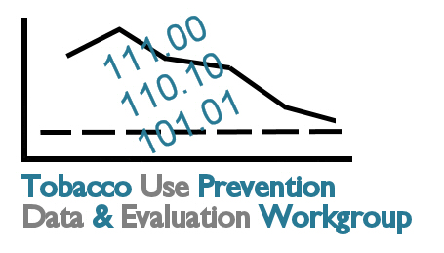
Tobacco Data and Evaluation
Planning Process: Meeting 1
August 27, 2007
Topeka Public Library
Marvin Auditorium 101B
10:00 a.m. – 3:00 p.m.

9:45 Registration

10:00 Welcome...........................................................................................................................Paula Marmet

10:10 Workgroup Logistics Connie Satzler
Workgroup Introductions

10:30 Charge to Group: Purpose of Planning Process................................................................Harlen Hays

10:40 Tobacco 101......................................................................................................................Carol Cramer

10:50 Healthy Kansans 2010..............................................................................................Brandon Skidmore

11:10 Break

11:20 Overview of CDC Evaluation Process.................................................................................Harlen Hays

11:30 Kansas Tobacco-Related Data Resources and Performance Measures............................Harlen Hays
Discussion

12:15 Lunch (on your own) and Networking

1:00 Review of Goal Area 1: Preventing Initiation of Tobacco Use among Young People........Harlen Hays
Small Group Discussion

1:30 Review of Goal Area 2: Eliminating Nonsmokers’ Exposure to Secondhand Smoke........Harlen Hays
Small Group Discussion

2:00 Review of Goal Area 3: Promoting Quitting Among Adults and Young People..................Harlen Hays
Small Group Discussion

2:30 Review of Goal Area 4: Identifying and Eliminating Tobacco-Related Disparities
Overview of Tobacco Prevention for Specific Populations Strategic Plan.......................... Karry Moore
Small Group Discussion

2:50 Next Steps and Workgroup Tasks Connie Satzler

3:00 Adjourn

Next Meeting: 10 a.m. – 3 p.m., Wednesday, September 5th, Marvin Auditorium 101C

Questions before the next meeting? Contact Connie Satzler, (785) 587-0151 or csatzler@kansas.net or check the
workgroup website: www.healthykansans2010.org/TUPP

