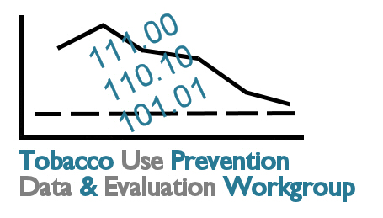
Goal Area Small Group Discussion Worksheet

Name:

Organization:

Goal Area 1: Preventing Initiation of Tobacco Use among Young People

- How does this logic model directly impact your organization?

- How does this logic model indirectly impact your organization?

- Do you currently collect information related to any outputs or outcomes?

- What vital information is missing with regards to tobacco use prevention?

Goal Area 2: Eliminating Nonsmokers’ Exposure to Secondhand Smoke

- How does this logic model directly impact your organization?

- How does this logic model indirectly impact your organization?

- Do you currently collect information related to any outputs or outcomes?

- What vital information is missing with regards to tobacco use prevention?
Goal Area 3: Promoting Quitting among Adults and Young People

- How does this logic model directly impact your organization?

- How does this logic model indirectly impact your organization?

- Do you currently collect information related to any outputs or outcomes?

- What vital information is missing with regards to tobacco use prevention?

Goal Area 4: Identifying and Eliminating Tobacco-Related Disparities
“Everyone Benefits: Kansas Tobacco Prevention for Specific Populations”

- How does the Specific Populations strategic plan directly impact your organization?

- How does the Specific Populations strategic plan indirectly impact your organization?

- Do you currently collect information related to any Goal Area 4 outputs or Specific Population strategic plan issues or objectives?

- What vital information is missing with regards to tobacco use prevention?

