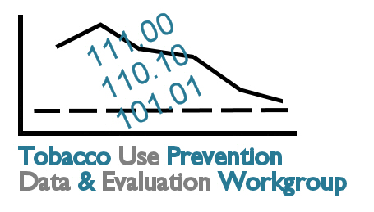

Tobacco Data and Evaluation Planning Process: Meeting 1 Feedback Form

Please complete this evaluation form by the end of the day. Your feedback is important. Please continue your comments on the backs of the pages, as needed.

 | Strongly Agree | Agree | Neutral | Disagree | Strongly Disagree
- Based on the information presented at today’s meeting, I have an adequate understanding of…
- My role and responsibilities as a workgroup member | ❑ | ❑ | ❑ | ❑ | ❑
- The goals of the project | ❑ | ❑ | ❑ | ❑ | ❑
- Comprehensive Tobacco Use Prevention | ❑ | ❑ | ❑ | ❑ | ❑
- Healthy Kansans 2010 | ❑ | ❑ | ❑ | ❑ | ❑
- CDC’s Evaluation Process | ❑ | ❑ | ❑ | ❑ | ❑
- Kansas Tobacco-Related Data Resources | ❑ | ❑ | ❑ | ❑ | ❑
- Goal Area 1: Prevent Initiation Among Young People | ❑ | ❑ | ❑ | ❑ | ❑
- Goal Area 2: Eliminate Exposure to Secondhand Smoke | ❑ | ❑ | ❑ | ❑ | ❑
- Goal Area 3: Promote Quitting | ❑ | ❑ | ❑ | ❑ | ❑
- Specific Populations Strategic Plan | ❑ | ❑ | ❑ | ❑ | ❑
- Workgroup tasks due before the next meeting | ❑ | ❑ | ❑ | ❑ | ❑
- The workgroup’s next steps | ❑ | ❑ | ❑ | ❑ | ❑
Comments:

 | Strongly Agree | Agree | Neutral | Disagree | Strongly Disagree
- Participation and Outcomes
- There has been adequate time for getting to know each other and building a functional workgroup. | ❑ | ❑ | ❑ | ❑ | ❑
- I am sufficiently aware of the knowledge and expertise the other workgroup members bring to the process. | ❑ | ❑ | ❑ | ❑ | ❑
- There was adequate time for questions, answers, and discussion. | ❑ | ❑ | ❑ | ❑ | ❑
- The group made sufficient progress at this meeting. | ❑ | ❑ | ❑ | ❑ | ❑
- I see how my organization is relevant to this planning process. | ❑ | ❑ | ❑ | ❑ | ❑
Comments:

- What part(s) of today’s meeting did you find to be most valuable? Why?

- What part(s) of today’s meeting did you find to be the least valuable? Why?

- What recommendations do you have as we finalize Meeting 2 plans?

- Are there any other comments or suggestions you would like to share?

